MSFS FlightBag V 0.65.0.66

See (new V0.65) indications for updates from the previous version (V0.63)

# Flight bag providing …

* Standalone or Part of the MSFS HudBar Windows
* Shelf for image documents either JPG, PNG or GIF images for reference
* Airport centric Map display
* METAR retrieval
* Profile Calculator
* Performance and Touchdown data
* Notepad
* Route and document integration with SimBrief and MSFS Route and Flight files

**MSFS_FlightBag** is a standalone application but also integrated in the MSFS_HudBar application.

Both are the same and share the same settings, data and configuration.  
The integrated version attempts to gather the flight plan departure and arrival airports where the standalone version expects those to be entered in the Config. Tab – otherwise they are the same.

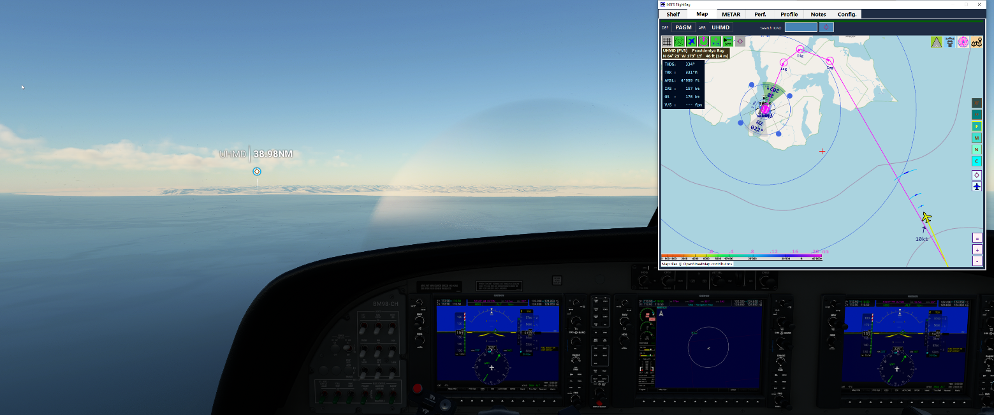

**IMPORTANT:**

**MSFS_FlightBag** makes extensive use of airport, runway and navigation data intended for the simulator.  
As one cannot distribute MSFS and/or Navigraph data via the application package the user must initiate the data collection and consolidation.

There is a program provided in the application package which does this chore.  
🡪 Below in the Appendix find the chapter **Data Loader** and proceed accordingly

Content

Flight bag providing … 1

Standalone Installation and Usage 3

Limitations 3

What is shown 3

Shelf Tab 4

Map Tab 5

Supported Map Providers 5

Map Display – Intentionally a zoomable but static map with decorations 6

Map – Ops 7

Airport / Area Information (updated V0.63) 8

Decorating the map 9

Aircraft tracking 9

Navaids 10

Airport VFR Marks 11

Selecting a runway for VFR or IFR approach waypoints decoration 11

Routes 12

METAR Tab 13

Perf. Tab 13

Profile Tab 14

Notes Tab 15

SimBrief Integration 16

MSFS Flightplan Integration 17

METAR Data Retrieval: 18

Distributed Contents: 18

Appendix: 18

File Storage 18

Settings Files and Reset Configuration 18

Map Data retrieval and storage disclaimer (updated V0.63) 18

Data Loader 19

Instances 20

Issue Reporting: 21

# Standalone Installation and Usage

* Deploy the release all zip content in a folder (no installer provided or needed)

Best is to start MSFS first, then the Flight Bag (but the App should connect the sim in any case)

* Start MSFS2020 first and once the Main Menu is shown
* Start FS20_FlightBag.exe
* It attempts to connect to the Flight simulator in 5 sec intervals, but shows a red bar while it is not connected to MSFS
* Use the **Tabs** for Shelf, Map, METAR, Perf., Notes, and Config.
* To **Exit** and stop the program click the top right X mark

# Limitations

Some aircraft do not provide or do not synchronize data with the Simulator as expected.   
Such aircrafts maintain their own internal models and act properly but do not share or interact well with the generic simulation where the FlightBag takes the data from to track aircraft and selected airports.

# What is shown

At startup there is an empty Shelf, Map, METAR, Perf., Notes, and Config. Tabs.

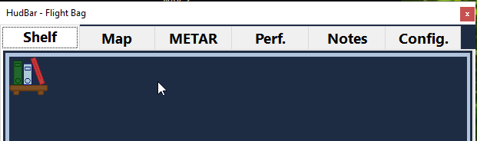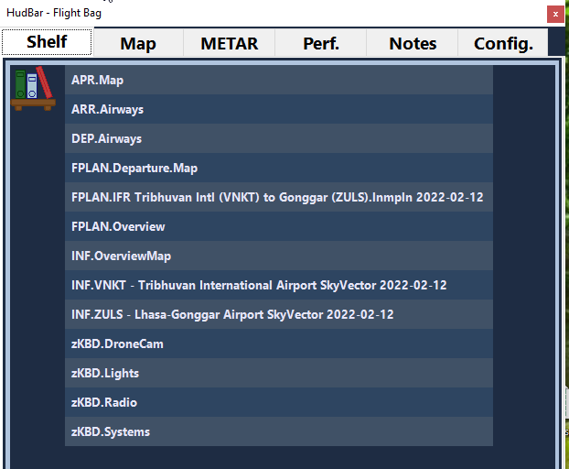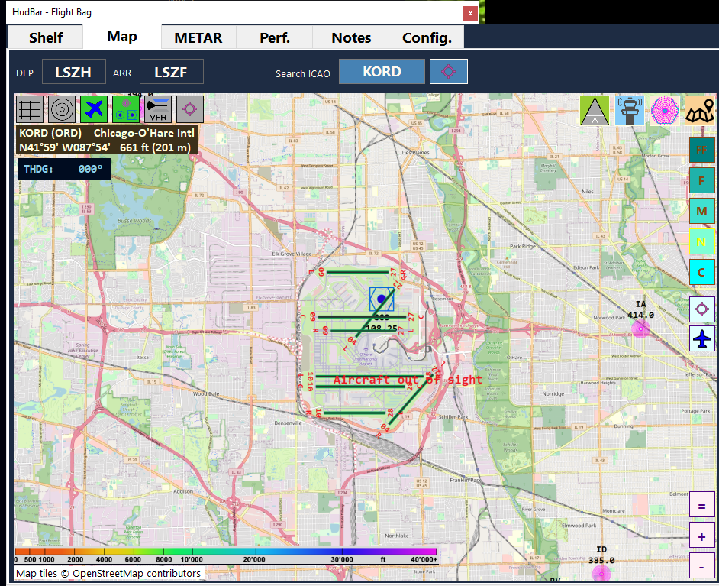

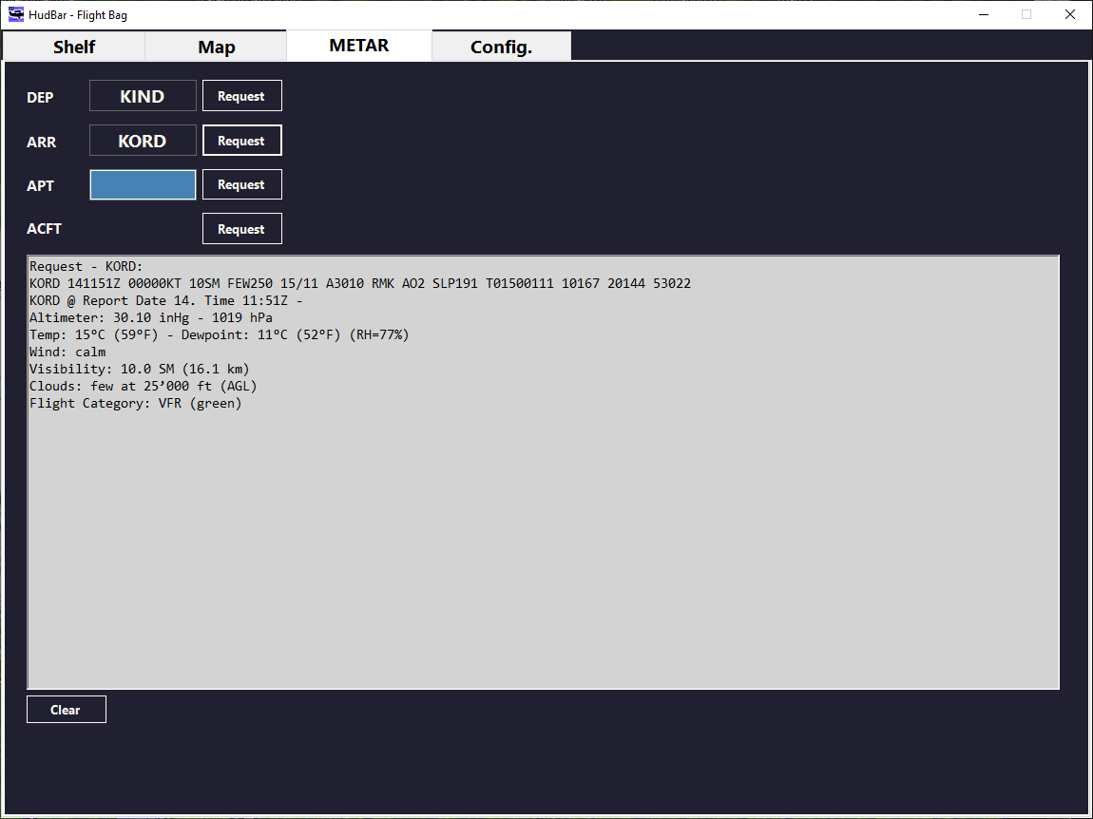 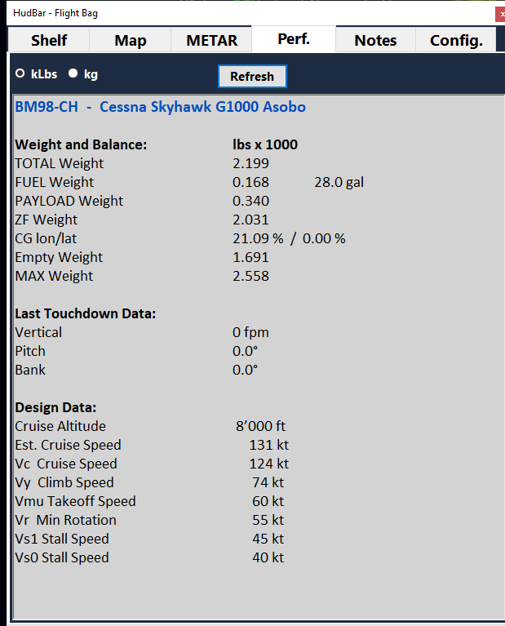 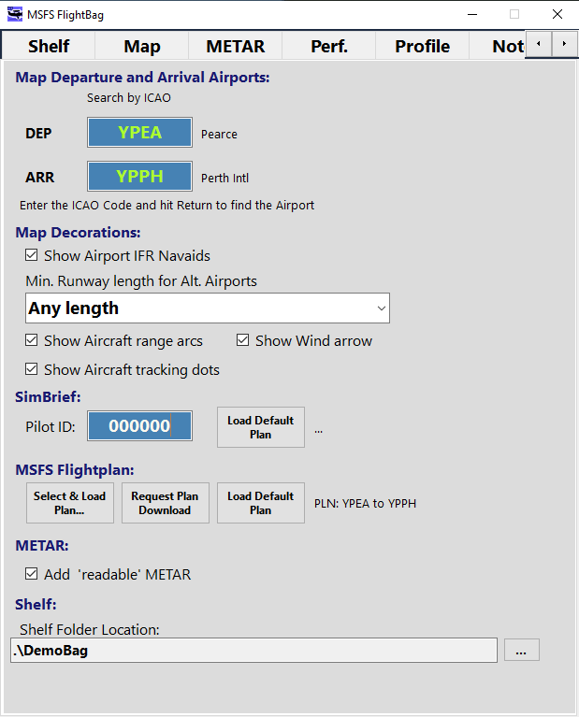

* Shelf provides a list of documents located in the selected folder
* Map shows a static map with various display options
* METAR allows to retrieve METAR information – if selected it translates the METAR string into something more readable.
* Perf. Lists Aircraft Performance numbers and Touchdown Data as reported from the Sim.
* Notes – a simple notepad area,
* Config. Allow to setup some options

See below for some of the items available

# Shelf Tab

* The Window allows to choose from image files contained in a folder.
* An image can be zoomed in or out and dragged within the window.
* Supported image file formats are PNG, JPG and GIF

Tip: scale the image in a way that the resolution is high enough to read it properly at the most used zoom level, usually this is around 1400 pix on the longer side – but you may try and find what works best.

Configuration:

In order to use the Flight Bag you must select the folder where your images are located – go to **Config**. Tab

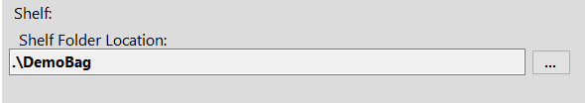

Default is the directory **DemoBag** in the App folder – supplied with some demo images in the App distribution.

Click ‘**…**‘ and choose any directory to use.

Usage:

The first time the window will open empty   
– Click the **Book Shelf Icon** in the top left corner to load the documents (images)

From the list of documents **click** the one to display.

**Zoom** the document with the mouse **scroll wheel** or **click the +- icons** in the bottom right corner.

Use the **left mouse click and drag** to move the document in the window.

**Click right** to reset the zoom and re-center the document.

Click the Book Shelf icon to select another document.

**Resize** the window as usual in Windows.

**Hide** the window with Hotkey, Context Menu or the X icon.

Example from the Demo included



# Map Tab

## Supported Map Providers

**MapLib** supports a fixed number of Map Tile Providers as well as 3 user defined ones.

* ALWAYS consider the terms of use for any of the map providers

**Free and open Tile services are at the time of writing** – enabled by defaultOpenStreetMap (OSM) and some derivatives

<https://www.openstreetmap.org>

OpenTopo, a 3d enhanced map from an open source project (usually rather slow to respond…).

<https://opentopomap.org>

Stamen 3d shaped terrain map (remote areas are rather slow to respond)

<http://maps.stamen.com>

**ChartBundle** - for US regions only (FAA provides data at no cost, other countries do not...) – disabled by default

<https://www.chartbundle.com/charts/>

Go for the Appendix MapLib Document – INI File - below to see how to enable them.

**Tile Services which need either a key or are subject to licensing terms** – disabled by default

Bing Maps (Microsoft map service) needs a key and subject to licensing

<https://docs.microsoft.com/en-us/bingmaps/getting-started>

ESRI/ARCGIS Tile Services as part of their offering – subject to license, don’t use if not licensed

<https://developers.arcgis.com/documentation/mapping-apis-and-services/data-hosting/services/image-tile-service/>

Remark:  
Don’t ask for Google Map support – I don’t have a key and they are rather complicated to work with…

**User defined tile services 1..6**

You may have an own tile service running on your NAS or know a tile service you like to use.  
**Provider Configuration** 🡪 Check the guide for MapLib (MapLib-Doc.pdf)

## Map Display – Intentionally a zoomable but static map with decorations

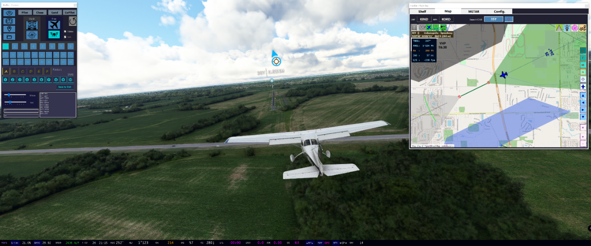

The Map display intends to minimize the performance footprint and will only request tiles on user request.

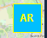There are 5 predefined ranges (XF=7, FF, F, M, N, C=15) which are loaded on demand and where the user can zoom in and out at discretion. *Note: decorations except the Route will be hidden above range FF.*

When in **AutoRange** (AR) mode it will zoom seamlessly between Z5 and Z15 levels of the map provider when zooming in or out.

When not in AutoRange mode (default) it will just zoom into the drawn image up to 20x magnification without switching to a more or less detailed map.

* The map is intentionally NOT a moving map. The user may shift the mapped area if desired.
* The map draws the selected airport runways if in sight and can be decorated with Navaids, VFR patterns, Aircraft
* The map displays and tracks the aircraft with some predefined essential data

## Map – Ops

MSFS Connect status LED   
(red, purple, green)

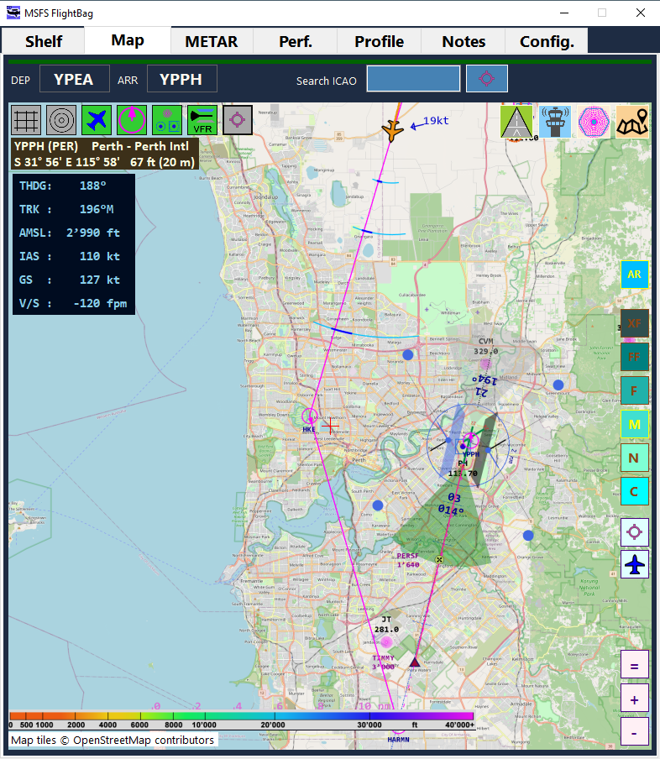

Left Click and Move Map

Scroll to Zoom In / Out

Tracked Aircraft data

Click HDG, TRK to toggle True/Mag°

Click Alt, Speed, VS to toggle Aviation / Si units

Reset Zoom

Zoom In / Out

Auto Range toggle

Map Range selectors  
XF, FF, F, M, N, C

Center Airport

Center Aircraft

Runway, Tower, Navaids, MapProvider List

Map Decorations

Selected Airport

Airport Search

Flightplan or config. Airports

The map is Airport centric – i.e. usually you would have an airport selected.  
Use Search Airport or click the DEP, ARR ICAO label to center the view on that airport (above it’s YPPH)

While in flight you may move the shown map area using the mouse with left click or use the ‘center aircraft’ button once in a while to re-locate the map.

For the selected airport one can list runways, tower frequencies as well as the area navaids.

*NOTE: for the time being the map may be a bit jumpy when moving it around rather fast. In the end it should show the expected area – if a yellow border remains, try to do a small move with the mouse.   
(Work in progress to clean it up)*

## Airport / Area Information

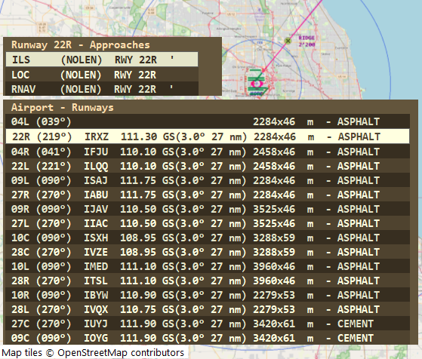

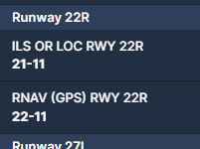 Approaches are shown as above, where the quote indicates that the data is from the Navigraph source. Such data is sometimes different or not available in the Sim.  
Above the LOC approach is from MS data and may not be available as separate chart in the Navigraph App.

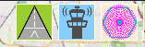

Clicking the Runway Icon will show/hide the list of airport runways found in the database.  
If there is an ILS located for the runway the ILS ID, Frequency, GS angle and range is shown.  
If there are Approaches for the selected runway found in the database it will show them above the runway panel as soon as you select (click) a runway.   
Selecting (click) an Approach will show the Approach as Waypoint/Line decoration in the map  
Selected items are highlighted (inverse coloring).

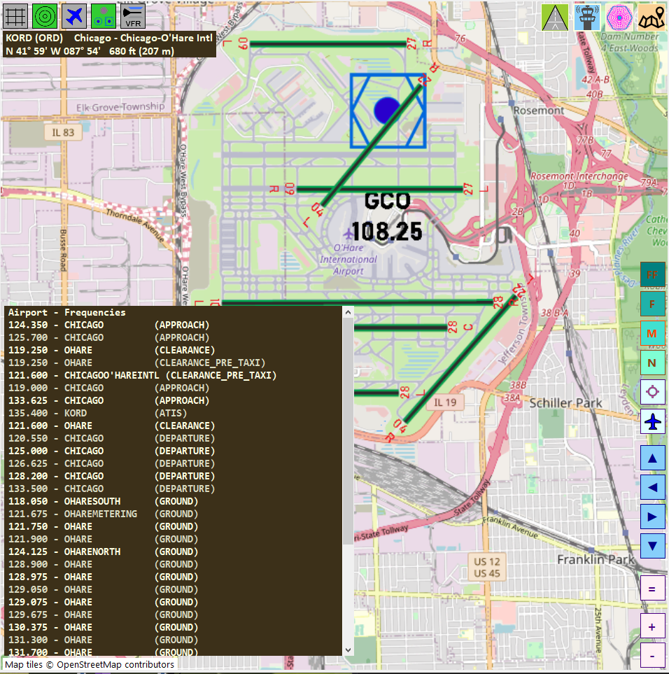 

Clicking the Tower Icon will show/hide the list of airport communication frequencies found in the database.  
When there are many like at KORD it will turn into a scrollable list.

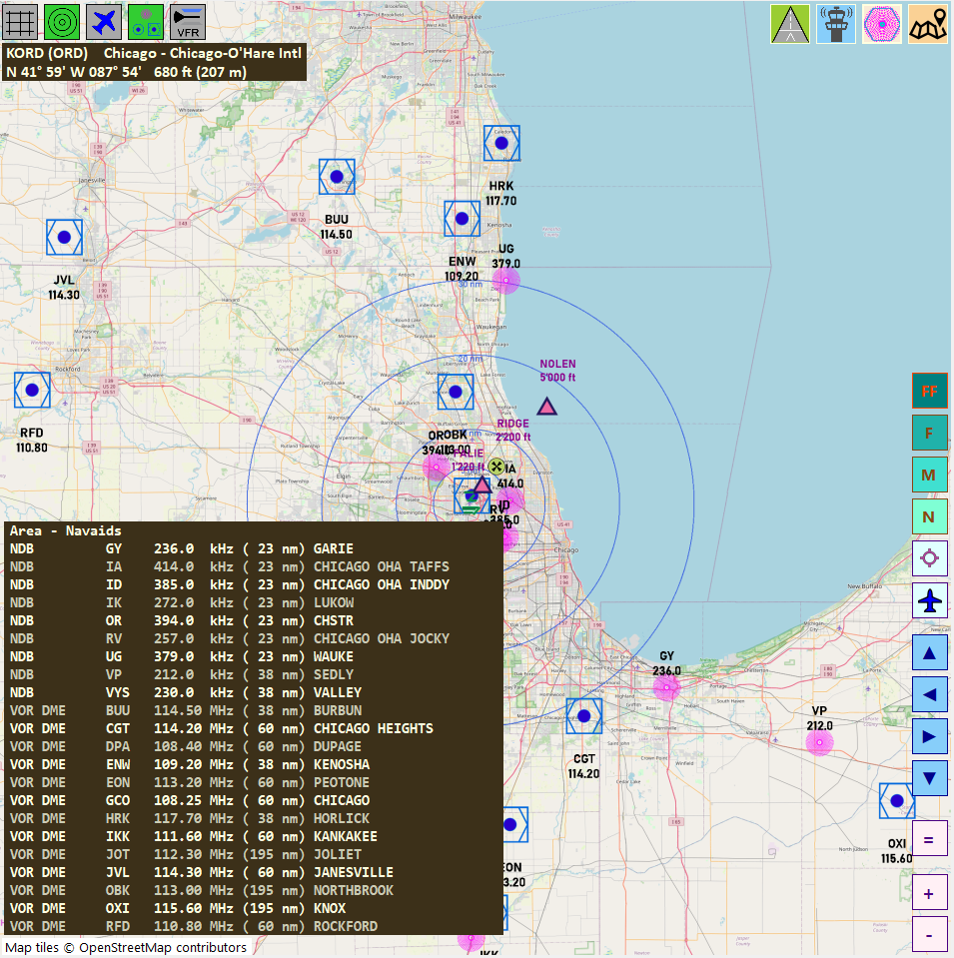 

Clicking the Navaids Icon will show/hide the list of the mapped FF Area VOR/NDBs and frequencies found in the database.  
Note: Whether or not showing the Navaids on the map is part of decoration selection.

## Decorating the map

* 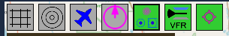 Map Lat/Lon Grid – toggles the grid
* Airport range circles (5, 15, 30, 60 nm radius)
* Aircraft tracking with some data points
* Route from SimBrief or MSFS Plans
* Navaids
* Airport VFR Markings
* Airports within the shown area (use Config. to select a minimum runway length)

**Click** to toggle visibility of the items

### Aircraft tracking

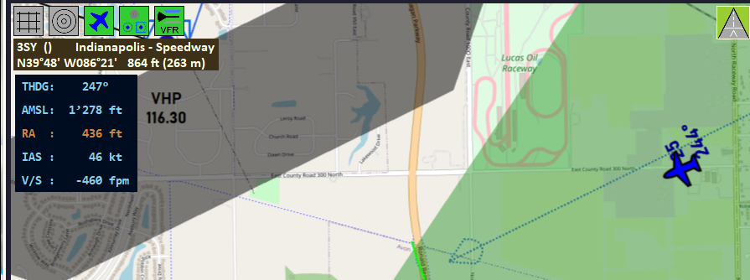

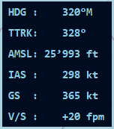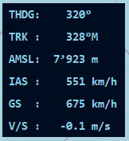When visible it will show the aircraft on the map if in the shown area, else it says ‘aircraft out of sight’.  
Data points are: (click an item to toggle either True/Mag or toggle Av/SI units

* True Heading (THDG)/ Mag Heading (HDG)
* True Track (TTRK) / Mag Track (TRK)
* Altitude above MSL in ft / m
* RA in ft / m (<1500)
* IAS in kt / km/h
* GS in kt / km/h
* V/S in fpm / m/s

The aircraft has a range feature which either shows 30° arcs at 2.5, 5, 10 nm out in light blue, the true ground track is marked with a 6° dark blue segment. These are TRUE degrees on the true north oriented map.

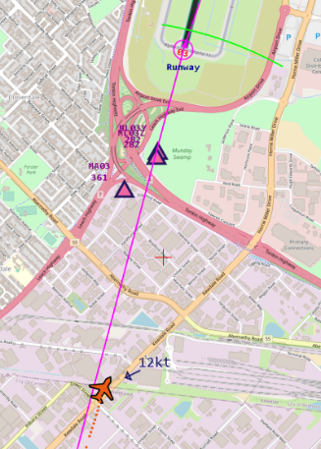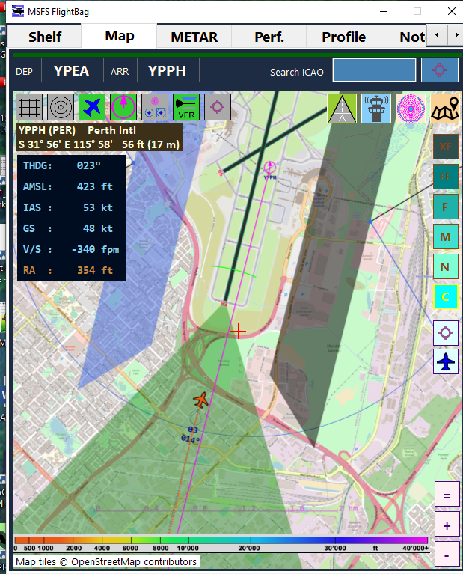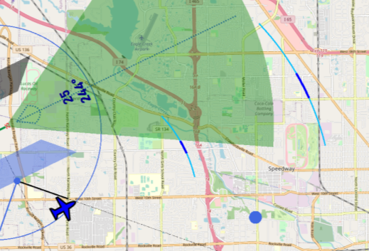  
Under approach conditions the range marker changes to the expected ground contact at current IAS, VS and altitude which is shown as a green 20° arc (at the time of writing this feature needs some improvement…)

Wind speed and direction is shown as arrow with the speed label

The wind speed is default in kt but when changing units to SI it will be m/s

### Navaids

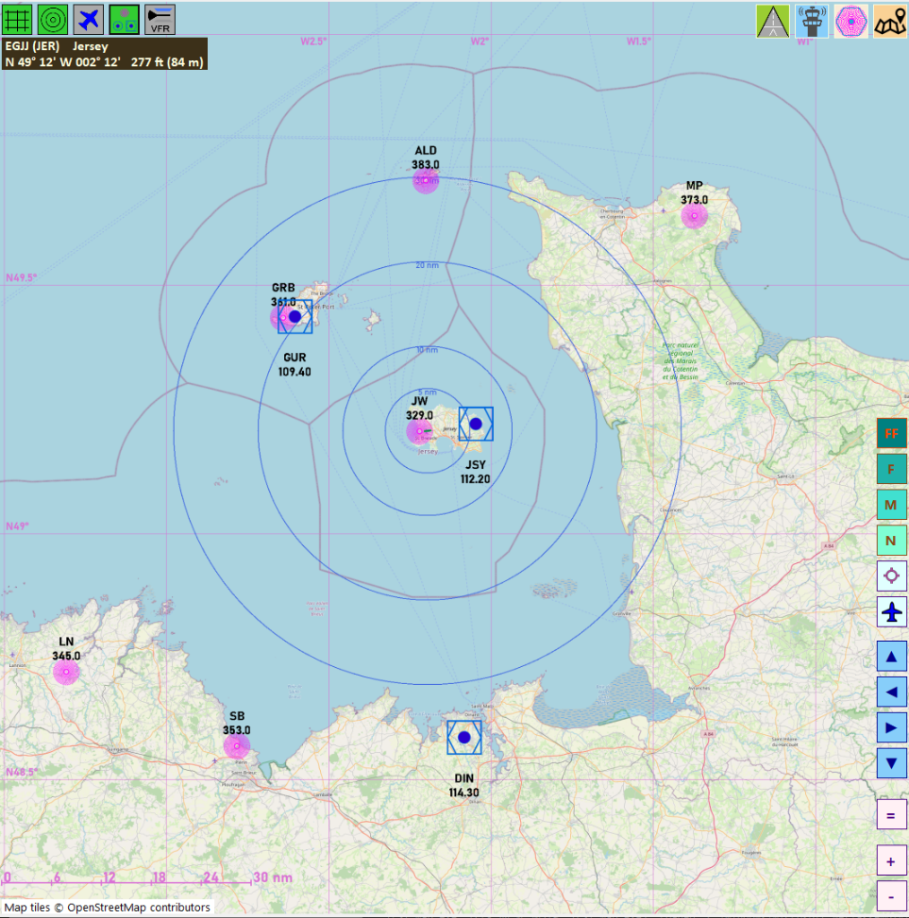

**VOR**, **DME**, and **NDB** navaids are shown with ID and frequency at their location.  
There is no further interaction available.  
**Waypoints** for runway approaches can be shown if a runway AND approach is selected from the runway list.

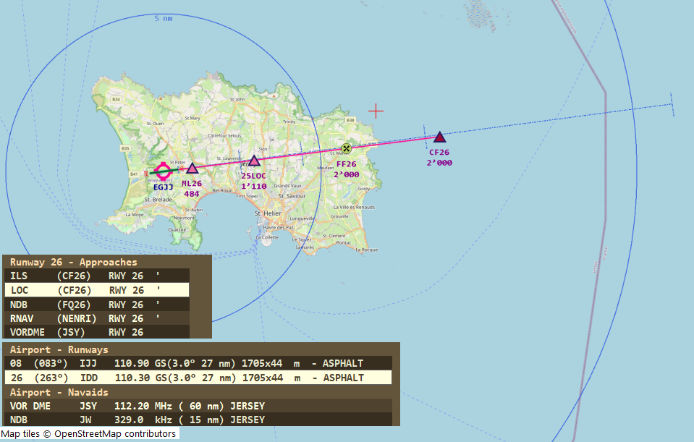

Above the runway 26 and the LOC approach was selected (clicked), Approach waypoints with their assigned altitude found in the database are placed on the map.   
Since V0.63 only the waypoints for the selected approach are shown also when Navaids are disabled   
(it allows for less clutter and more readable labels)

Also when selecting a runway a blue dotted line towards the runway is shown with steps at 2, 4, 8 and 16nm from the runway start.

### Airport VFR Marks

Note: this feature may or may not please all kind of pilots – please let me know …

### Selecting a runway for VFR or IFR approach waypoints decoration

To select a runway get the Runway list and **click** one of the runways.   
To **clear** the selection, click the ‘Airports – Runways’ text (hand appears) and the decorations will go away.

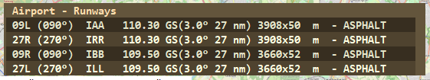

For a selected runway VFR marks are shown.  
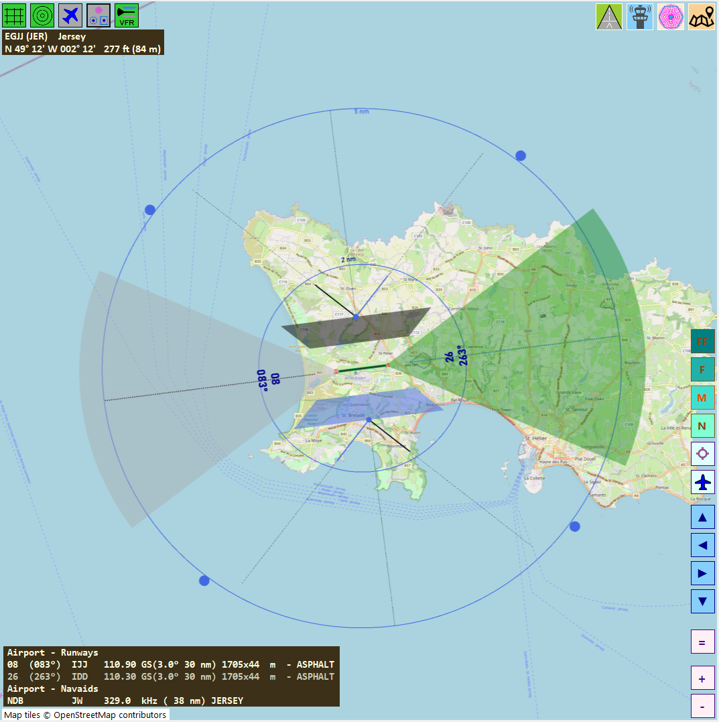

2 nm radius circle

5nm out entries at 45°

+-30° outbound arc

Left (blue) / Right (black) pattern area 0.5 .. 1 nm with 45° entries

Rwy ID and bearing (mag deg)

+-30° inbound arc

Above the runway 26 was selected (clicked)

To select an approach click the line item.  
To **clear** the approach selection, click the ‘Runway xy – Approaches’ text (hand appears) and the decorations will go away.

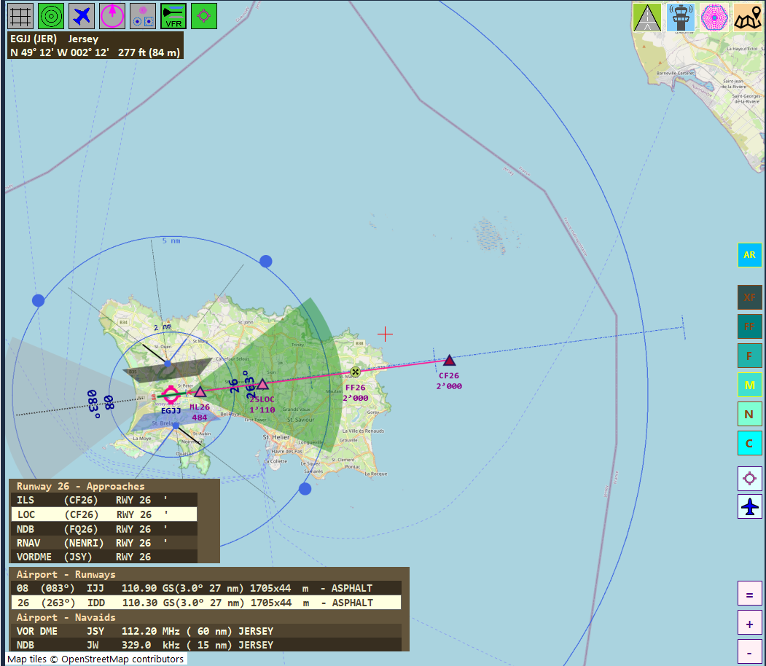

When VFR marks is on and an approach is selected it looks like above.

### Routes

Routes derived from SimBrief or MSFS Plan- or Flight files are shown when the Route icon is clicked.

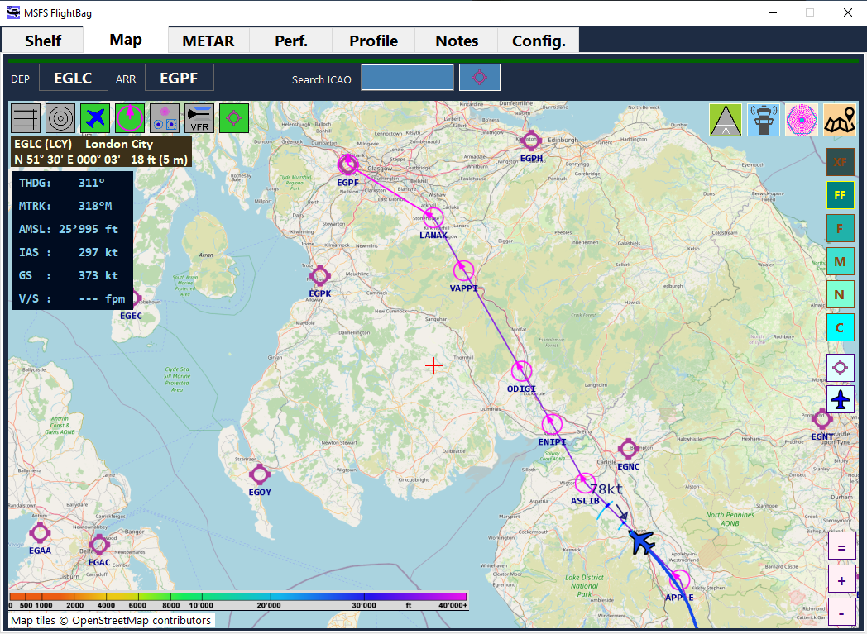

A route is marked with magenta lines and circles, where legs belonging to a SID or STAR are shown in a darker magenta color as in the example right from waypoint APPLE to LANAK.

As long as there is no Approach information in a plan the last leg ends at the airport (ex. LANAK-> EGPF)

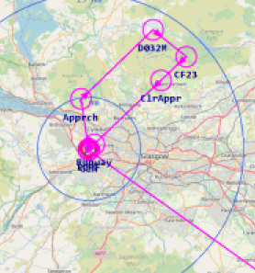Requested plans from the Sim may eventually contain Approach information. Such data is created by the Sim ATC/Planner and the validity is sometimes questionable…

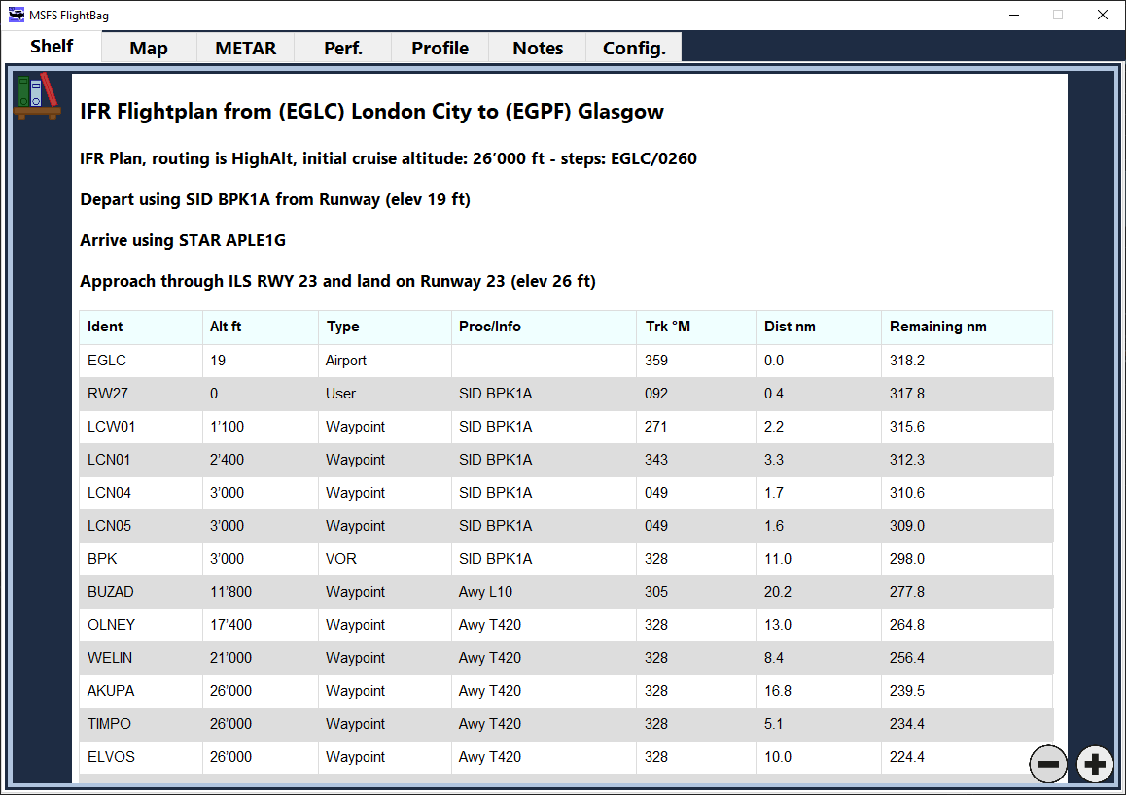

*It is also dependent of the aircraft flown, some FMS do not share plans with the Sim internal systems and will therefore not provide any meaningful information in MSFS derived plans.*

For **any** plan a flight table document is created in the Shelf (**@.FlightTable**). The table contains a row for each waypoint found in the plan together with some helpful information about the plan.

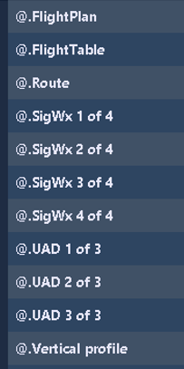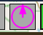For SimBrief downloads the plan document @.FlightPlan is created and the images contained in the plan are downloaded if available and stored in Shelf.

To the right is the list of docs for a SimBrief download.

***Note: plan documents are overwritten as soon as a new one is created or downloaded.  
But the currently viewed document does not change – select it again to view the most recent version.***

# METAR Tab

This Tab will return METAR information for the station where the **Request** button was clicked.



If set in Config it will ‘translate’ the telegram into a more readable version as shown above.

If METAR does not provide data it might be that the service does not respond (try again in a few seconds) or the station is not available at all.

**The ACFT** will ask for a station based on the aircrafts LAT/LON position from the nearest weather station found within max. 500 Statute miles in direction of flight, the returned station is sometimes not really what one expects, but what the Metar server provides… (Cannot change it though).

**The Metar is real weather information at the location i.e. suitable when using Live Weather.**  
– MSFS Sim weather cannot be retrieved outside the sim.

# Perf. Tab

Performance data as reported from the Simulator.  
Touchdown data as reported from the Simulator.  
There is a Touchdown log saved (MyDocuments\MSFS_HudBarSave\TouchDownLog.csv) when using the FlightBag

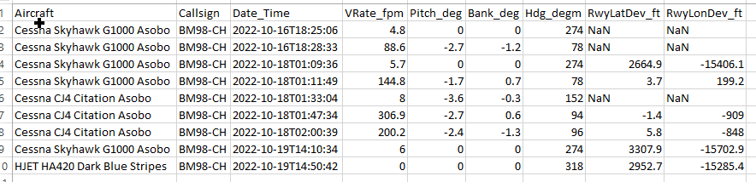

You may find Runway Deviation sometimes NaN or off by miles. The deviation is derived from the ATC assumed runway – which sometimes is just not set (NaN) or is still the starting runway (number is far off).  
Also when you bump at the takeoff (happens…) you see most likely a separate line with a small number for the VRate (e.g. line 2)

# Profile Tab

An interactive profile table – using the “Rule of 3” as base.

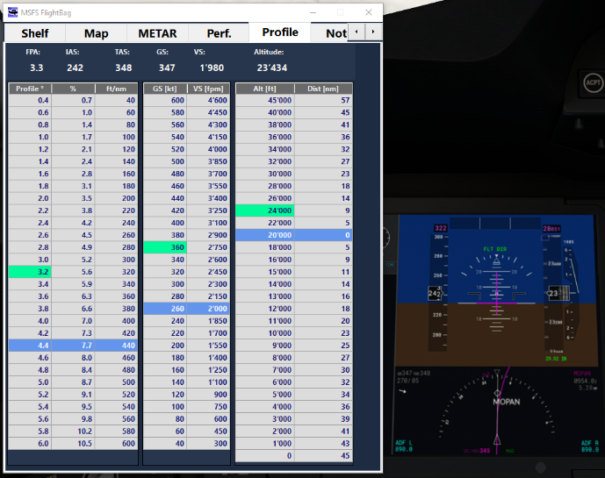

Above the tables are the current numbers as reported from the Simulator:  
*FPA is the current flight path angle then IAS, TAS, GS, VS, and Altitude (in kts and Alt in ft)*The current FPA, GS, and Altitude values are highlighted in the respective tables with a greenish color (for values in between row values for GS and Alt the higher one is marked in order to provide a safety margin).

**Click** a flight profile row in the left table - it will recalculate the 2nd and 3rd table.

The middle table shows the required vertical speed at a given **ground speed** (GS) in order to maintain the profile. E.g. above to maintain a 4.4° profile at GS of 260 kts it asks for 2000 ft/min vertical rate.

**Clicking** a row in the middle table serves only as mark or reminder and will not change any value.

The right table shows the distance which is flown to get to a certain altitude at the selected profile angle. E.g. starting from FL200 with a 4.4° profile it needs 23nm to get either down to FL100 or up to FL300.  
Note: add a safety margin to the calculated distances!

**Clicking** a row in the right table will set this altitude as zero distance and calculate from there up and down.

There are no signed numbers in the tables, it’s meant as either climb or descend.

Example:

We are at 26’000 ft with a GS of 480 as the greenish marks are showing, above the table are the real-time values from the Sim.  
The plane is heading down at 2.4° and this profile is currently selected - showing a VS of ~2000 ft/min is required and flown.

Below the left screen has 26’000 ft selected as starting point and the distances are calculated up and down. To get down to 7’000 ft it shows we need about 79nm.  
In the middle screen the new target altitude of 7’000 ft is selected and it shows the remaining distance as the green mark walks down while we descend. Also showing the needed distance to the airfield which is at about 1’000ft – it would be 25nm when flying at 2.4°.  
In the right screen the approach profile of 3° is selected and now the VS has changed but also the distance from 7000 to 1000ft is back to 20nm for the steeper approach (now we only need to get our speed back in time and maintain the profiles..)  
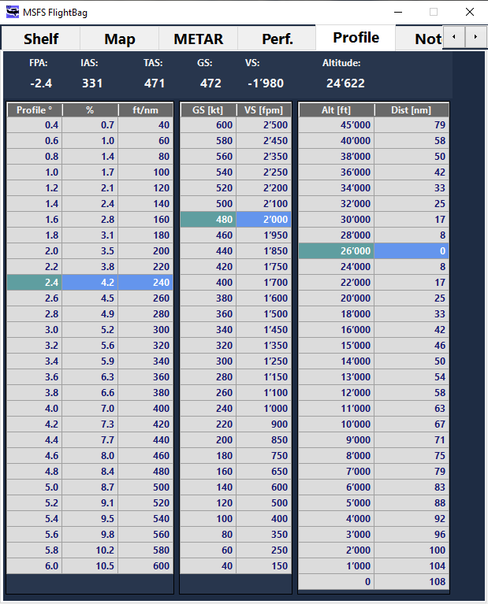 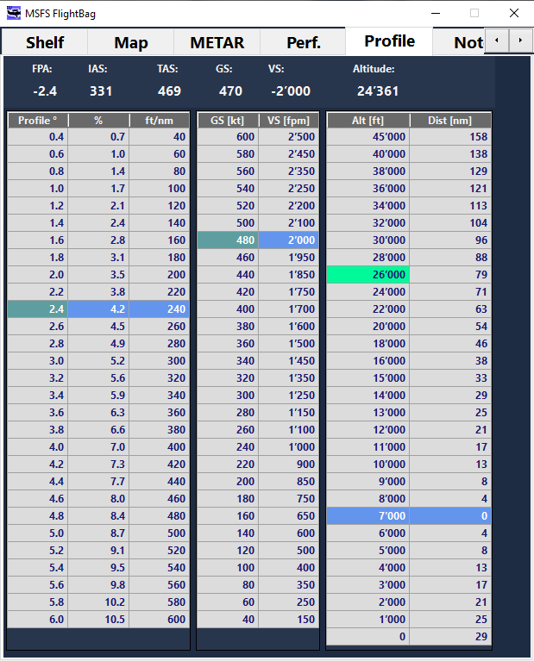 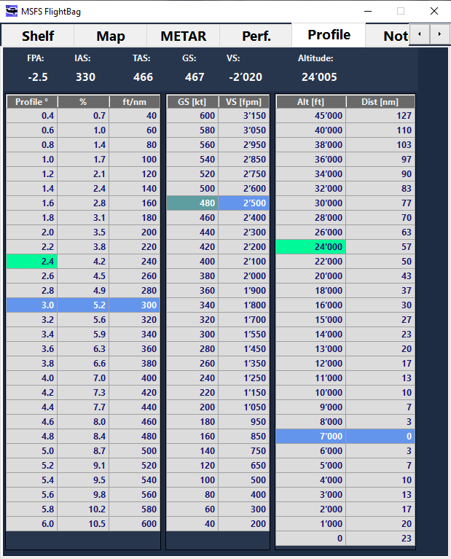

Can be used to estimate the TOD or to check if a constraint can be made with the current profile.

# Notes Tab

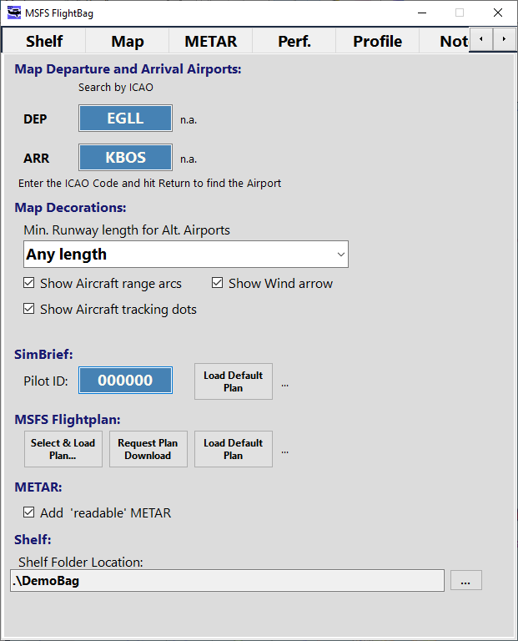just a notepad which is saved when closing the App

Config Tab

Set the desired **Departure** and **Arrival** **Airports**

Enter the ICAO code and hit the Enter key – if the airport is found it will turn green and the common name is shown right to it, else it will turn red, indicating that ICAO code was not found in the database.

**Map Decorations:**

Min. **Runway length for Alt.Airports**’ lets you select the minimum length for any runway an airport must have in order to be shown when Airports decoration is ON. Choose a min length from the drop down.

Checked ‘**Show Aircraft range arcs**’ will show the leading arcs of the tracked aircraft when Aircraft decoration is ON.

Checked ‘**Show Aircraft tracking dots**’ will show the trailing dots of the current tracked aircraft when Aircraft decoration is ON.

Checked ‘**Show Aircraft Wind arrow**’ will show an arrow of wind direction and the speed of the wind around the aircraft.

**SimBrief:**

Enter your SimBrief PilotID (a 2..7 digit number), hit Return to validate it (once – it will be stored in Settings)

Then click “**Load Plan**” to retrieve your latest Flight Plan – it will reply the Departure and Arrival Airport and also fill in the corresponding fields above.

**MSFS Flightplan:**

Select a PLN or FLT file from the disk, request the ATC plan from the Sim or load the default plan from MS to load a route and create a Plan Table document in the Shelf.

**METAR:**

Checked ‘Add ‘readable’ METAR will show the more readable METAR information along with the received telegram.

**Shelf:**

**Shelf Folder Location**: click the button <…> to select a folder where the images for the Shelf Tab can be found.

* The Configuration is shared for the standalone and the HudBar version of the FlightBag.

# SimBrief Integration

If you are using SimBrief for your flight planning you may retrieve the latest plan and some documents now.

First provide your Pilot ID (a 2..7 digit number) in Configuration, it will be stored in Settings.  
Use “**Load Plan**” in Configuration to retrieve the last plan data.  
Once successful a Flight Plan document is stored in the Shelf together with the pictures created by SimBrief.

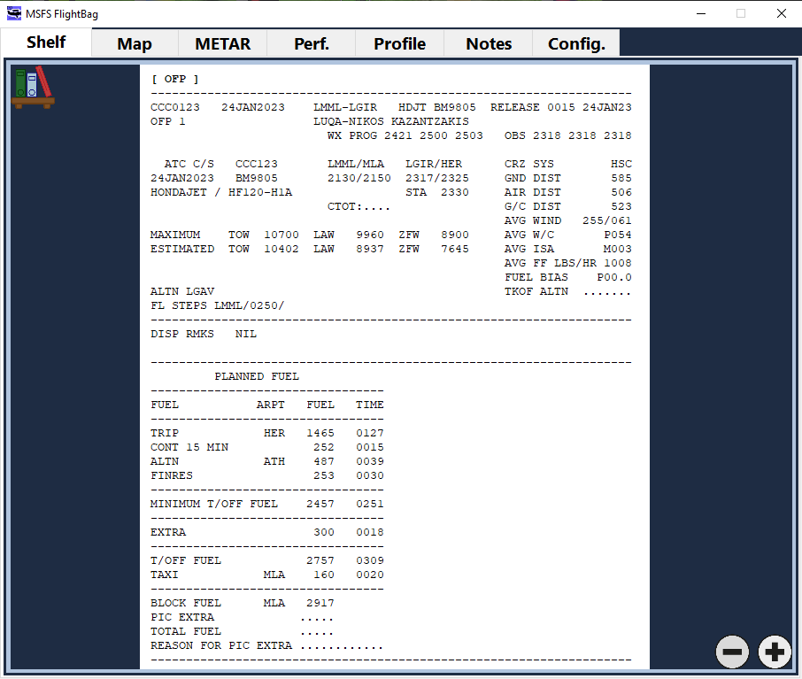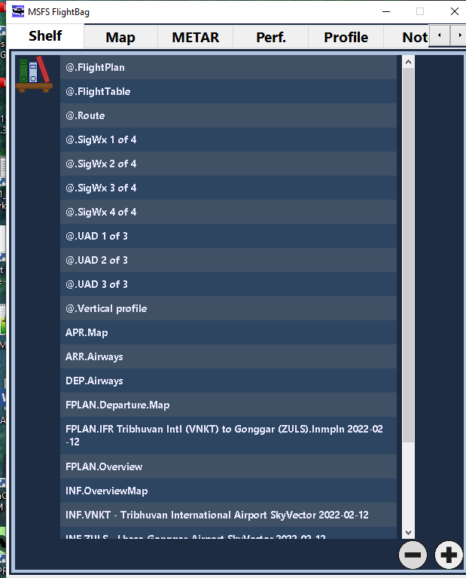

In Shelf you will find the documents starting with **@.** … (e.g. @.FlightPlan, @.FlightTable, etc)

@.FlightPlan is the main plan where the long NOTAM and image sections have been stripped from.  
It is stored as one Image document and can be read, zoomed and scrolled like any other doc.

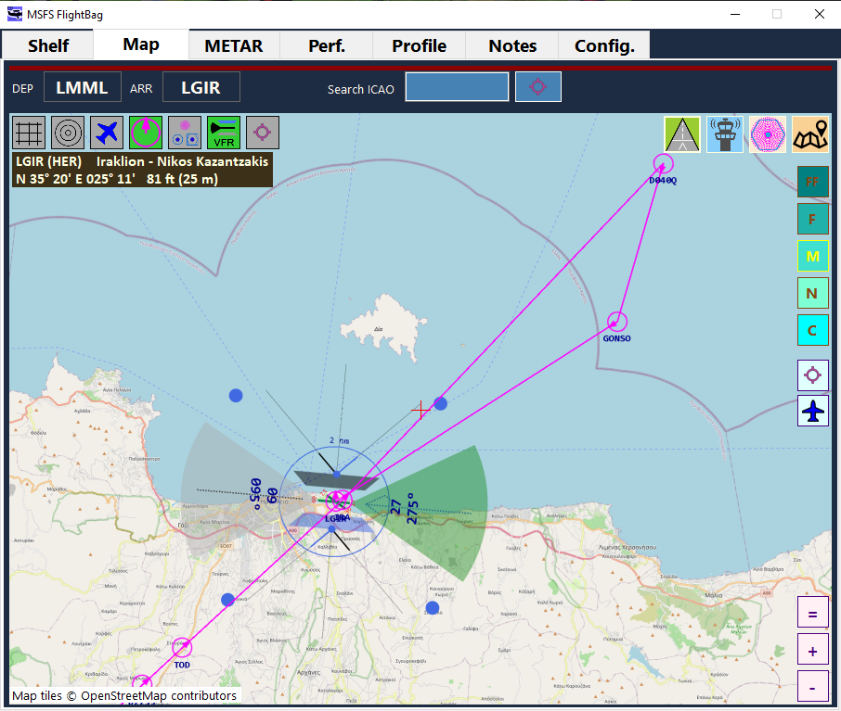For the Map display the planned route is shown (can be toggled on and off) using this button:

While the route is shown as magenta line the waypoints are circles with the ID below.

Note:

The plan does not include approaches and therefore the last segment is usually pointing at the airport, rather than the approach path.

In the example the plan is to land on runway 27. With the VFR runway display one has at least a rough overview of the approach pattern needed.

*Note: There are some settings in SimBrief which may disable the availability of images in the download, check SimBrief Settings for details.*

# MSFS Flightplan Integration

In Config you may load either the default MSFS Plan (CUSTOMFLIGHT.PLN in the MISSIONS folder) or request the most current Simulation ATC FLT plan or select a PLN or FLT Flightplan file from any location on the computer.

MS Plans will load the route and also a flight plan in table format is created and saved in the Shelf  
the name is: @.FlightTable

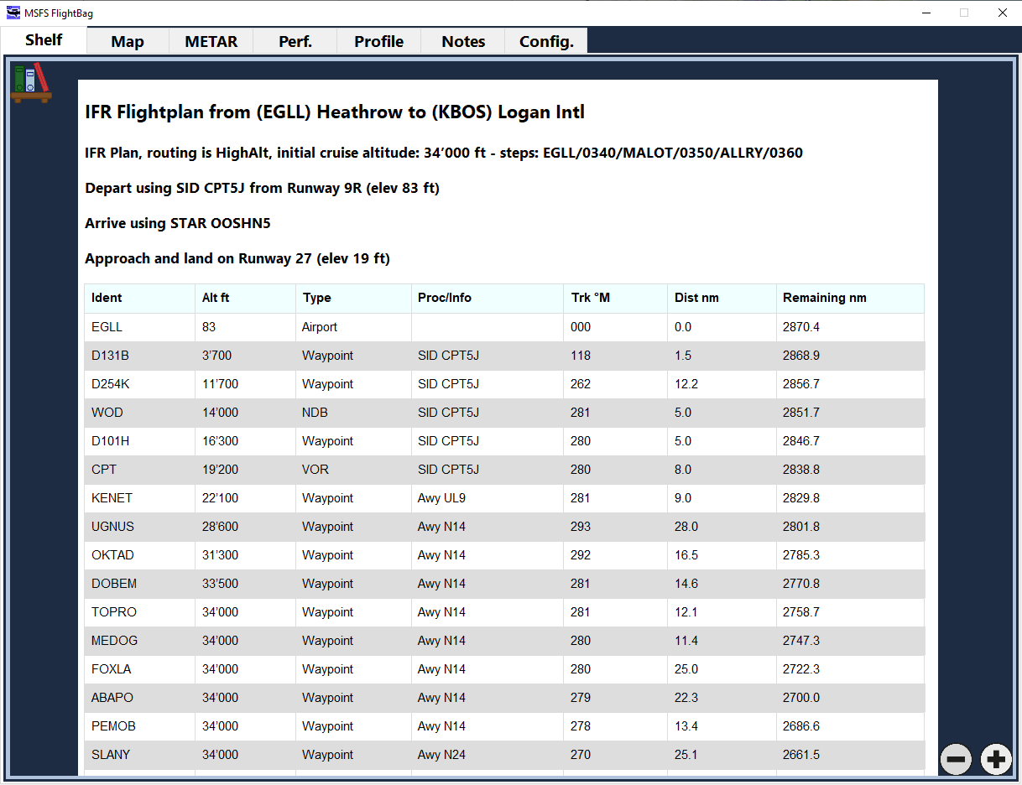

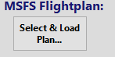The above is from a flight planned in SimBrief where the MSFS2000 (PLN) file was downloaded and loaded in Config Select & Load Plan…

The new XF Range allows a larger overview of such a plan.

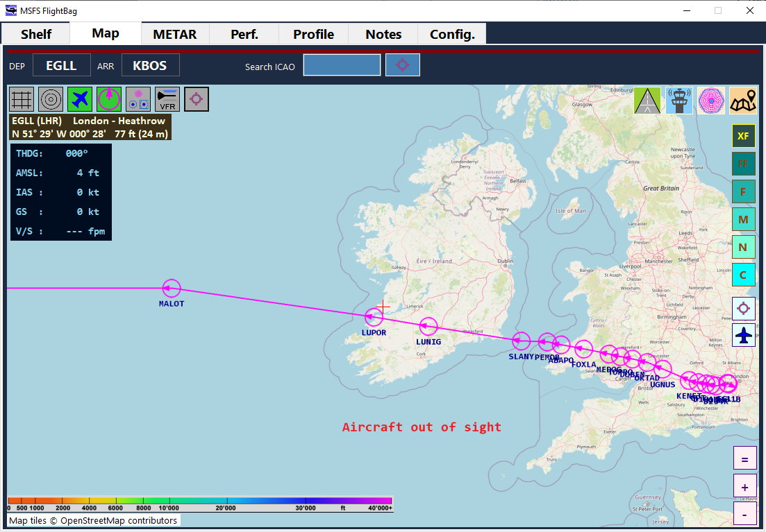

*Note: You may use both SimBrief and MSFS Plan loading without having the Simulator running.*

# METAR Data Retrieval:

Please note that the program will issue HTTP Requests to an external server to retrieve the latest METAR information.  
The data for METAR is retrieved from: **https://aviationweather.gov**

**Please make sure to comply with their terms and conditions when retrieving METAR data with this program.**

See also: https://aviationweather.gov/dataserver/example?datatype=metar

# Distributed Contents:

My FlightSim Libraries (included in the release package)

SEE README.TXT FOR THE LIST

CoordLib is based on: https://github.com/chrisveness/geodesy  
Translated to C# and partially modified   
Original code license: The MIT License (MIT)

# Appendix:

## File Storage

Files are generally stored in the “<MyDocuments>\MSFS_HudBarSave” folder

## Settings Files and Reset Configuration

The configuration is stored in using a Json AppSettings Library.

The configuration can be found here: <MyDocuments>\MSFS_HudBarSave\settings\<APP>

For the Flight Bag, the settings file is: FShelfAppSettings.json   
This file stores your configuration but I suggest to not edit it – unless you know what to change, it may prevent the program from starting if done wrongly.

If you find something really wrong – you may backup and delete the settings file and the program will use the defaults to start with.

## Map Data retrieval and storage disclaimer

Map cache files:

The map cache files can be found here: <MyDocuments>\MSFS_HudBarSave\cache\<Provider>.dblite

**MapLib** retrieves tiles only for the user requested location and zoom level.  
The visualization WinForms UserControl **bm98_Map** requests tiles as a matrix of 8x8 tiles at zoom levels for the 6 different ranges: XF=7, FF= 9, F=11, M= 12, N=13, C=15  
With **AutoRange** enabled it will load tiles from zoom level 5 to 15 when zooming the Map

**MapLib** stores tiles per provider in a computer local disk cache and will clean up tiles older than 100 days or when the providers cache exceeds ~128MB / ~5120 tiles at startup of the application.

**MapLib** maintains a memory cache for 800 tiles (about 20MB RAM) while an application is running.   
🡪 If you encounter incorrect tiles or other oddities – first delete the cache files and try again.

**Provider Configuration** 🡪 Check the guide for MapLib (MapLib-Doc.pdf – at the end of this document)

V0.65 updated the download task to comply with OSM policy i.e. only 2 concurrent threads.

## Data Loader

Go for the application folder and then into the subfolder \dataLoader

Run FacilityDataLoader.exe:   
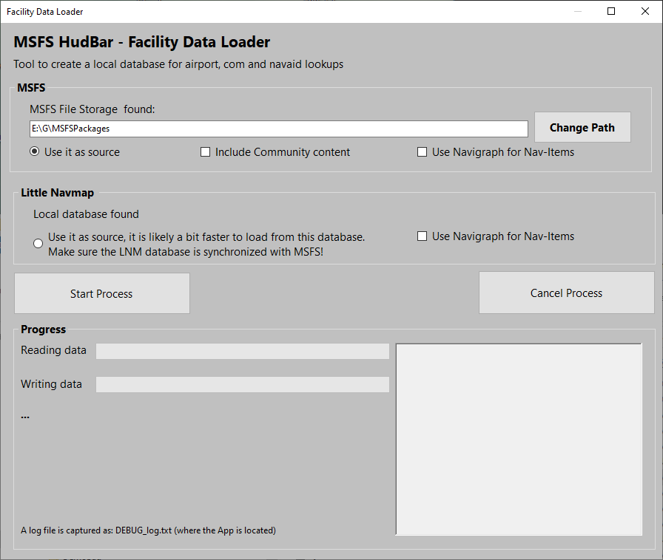

First check if the program finds the MSFS data path.  
It does follow the MS specs for Store and Steam but…

If not you may need to use Change Path.. to point it to the folder (where Community and Official folders can be found)

If the LittleNavMap database is found it will show it as well.

You may choose the source for the data, either collecting from the MS files where you may include Community content and/or Navigraph (if installed)

Or from the LittleNavMap database which is usually faster.

Check one of the sources.  
Then hit Start Process and have some patience.  
The program will report progress and once it finished its data collection it will tell you.  
The database is stored at MyDocuments\MSFS_HudBarSave\db\fs2020genApt.dblite and is around 200MB.

REDO this process when either a new Navigraph version is out and when MS provides substantial updates.

## Instances

You may want to start the FlightBag more than once or get independent configurations and therefore programs running.

However they share the same Settings i.e. the location is saved from the last movement on any of the instances.  
In order to have truly independent instances with their own settings (all settings in Config and locations etc.) an Instance Name can be added to the Command Line when starting the FlightBag.

No command line parameter is considered and referred to as ‘Default’

If you provide an Instance name to start the FlightBag it will be shown in the Window Title (Window Bar and Configuration)

You may start instances the easy way by creating a **Desktop Shortcut** and then modify the **Properties** of the **Shortcut** (right click) by adding an Instance name to the **Target** field:   
This is the command line; add a space and the name at the end of the text field

Then may be rename the **Shortcut** in order to recognize it later.

## Issue Reporting:

In case you encounter a problem please include as much information as possible. Sometimes it is also relevant which aircraft you were using.

Issues can be reported directly via GitHub (or a Message in Flightsim.to)

<https://github.com/bm98/FS20_HudBar/issues>

<https://flightsim.to/file/41426/msfs-flightbag>

For issues with a flight plans – the App stores the most recent version in

MyDocuments\MSFS_HudBarSave as file with the name LastPlanDownload and the ending .FLT, .PLN or .json

PLEASE trigger the request again and then immediately save and include the files when reporting errors.

**Known Issues:**

***Stutter when requesting a Plan from Sim***

The Simulator may stutter for a moment when requesting a plan download- seems to be an ASOBO/MS issue since long ago. Cannot do anything about it…

***Settings are not stored or runtime exceptions***

We have seen issues when Windows Protected Folders are enabled.  
(<https://www.tenforums.com/tutorials/87858-add-protected-folders-controlled-folder-access-windows-10-a.html>)

In such a case Windows may deny programs which are not installed via MSI Installer access to write or delete files in some places, among them is the MyDocuments folder.

There is a check at the very beginning of the App which is trying to elaborate if such protection exists or not.  
If yes there is a MessageBox popping up related to Access Permission Error and the reason should be reported in the box.  
Is such a case first try to find out if protected folders are enabled and then add the FlightBag App to the list of allowed programs and start the program again to see if the problem persists – if it is still there head for Issue Reporting above.

(<https://support.microsoft.com/en-us/windows/allow-an-app-to-access-controlled-folders-b5b6627a-b008-2ca2-7931-7e51e912b034>)